

**FULL STACK PHP WEB DEVELOPMENT**

---------------------------------------------------------------------------------------------------------------

[POINT OF SALES]

FINAL TECHNICAL REPORT

Reporting Period: – [01 01] to [01 05], [2023]

---------------------------------------------------------------------------------------

Submission Date: 01 10, 2023

Project Start Date and End Date: [01 02, 2023] to [01 05, 2023]

Submitted by: [Abd-alrahman kreshan]

Supervisor: [Mr. Bisharah Estephan]

Tel: [96278363834]

Email: [9971005284.UPS@htu.edu.jo]

This document was produced for review by the al hussein technical university teams

Table of Contents

3. INTRODUCTION 2

4. Flow Chart Diagram 2

5. REQUIREMENT ANALYSIS 3

4. RESULT & DISCUSSION 5

5. MATERIALS AND TOOLS 5

6. CONCLUTION 5

6. References 5

**Table of Figure**

Figure 1 Flow-Chart-Diagram 2

Figure 2 Use-Case-Diagram 3

# 

# INTRODUCTION

A point-of-sale (POS) system is the software that helps your market business accept payments from customers and make sales. It also tracks sales performance, manage staff, collect customer contact information, and analyze inventory levels on an item-by-item basis.

You can even control inventory right at the cash register with point-of-sale (POS) software systems. POS software records each sale when it happens, so your inventory records are always up-to-date. Better still, you get much more information about the sale than you could gather with a manual system. By running transaction based on this information, you can make better decisions about ordering and merchandising.

In this technical report it shows how the system work along with flow chart diagram for clear understanding the idea and how system easy to use.

# Flow Chart Diagram

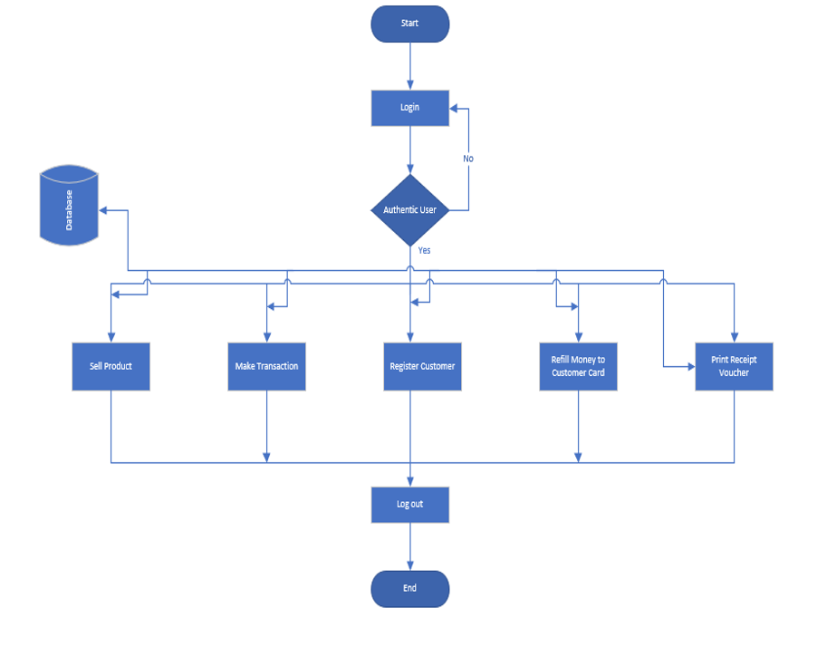

Figure 1 Flow-Chart-Diagram

3.1 Use-case-Diagram

The use case diagram for POS system is used to show the processes involved when users invoke the software. It depicts the structure of the system behavior.

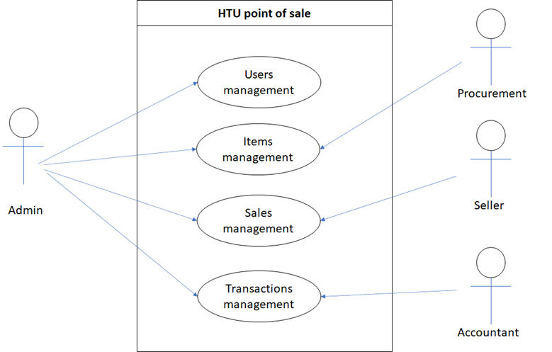

Figure 2 Use-Case-Diagram

# 

# REQUIREMENT ANALYSIS

This section presents the functional requirements of the proposed software system as data were collected via meetings with the managers and employees of the store. [1]

3.1 Functional Requirement

* The system supports customers purchased receipt.
* System can edit profile info.
* System can add stock.
* System can update stock.
* System can delete stock.
* System can show the sales report.
* System can register new item.
* System can add customer service.
* System can update customer service.
* System use api with send and receive data.

3.2 Non-Functional Requirement

**Performance**  
Response time in this system should be able to retrieve user request within less than 5s

**Security**System must guarantee that data about diverse types of user’s transactions must be treated in protected channel.

**Usability**  
Users with variety of background can simply easily use the system.

**Support**   
 administration, databases, and applications ought to be available round-the-clock.

**Availability**  
The system should be able to provide services on demand around-the-clock.

# RESULT & DISCUSSION

After using this software, we have got some result this is:

* Secure & portable
* Easy to use & User friendly
* Customizable
* Smart reporting system
* Fast performance
* Can you for store or restaurant

# 

# MATERIALS AND TOOLS

* MySQL
* Visual Studio Code
* Debugger
* Postman Tool
* Localhost Server

# CONCLUTION

This pos system is user-friendly and reliable computer based standalone system for mini- stores. It has been designed to manage the whole store’s information and general reports, we hope that this software will contribute in supermarket or restraints business inventory much.

# References

|  |  |
| --- | --- |
| [1] | S. Hasan, November 2015. [Online]. Available: www.researchgate.new . |
| [2] | G. Alder, "flowcharts," 2005. [Online]. Available: https://app.diagrams.net/. |
| [3] | T. q. c. universiy, "Studocu," May 2202. [Online]. Available: www.studocu.com. |